**Corrective Action Log Work Instructions-**

Open up the Format 5- located in the CPR folders (chose the correct processing month and hull)

Y:\EVMS\CAM_Notebooks\CPRs

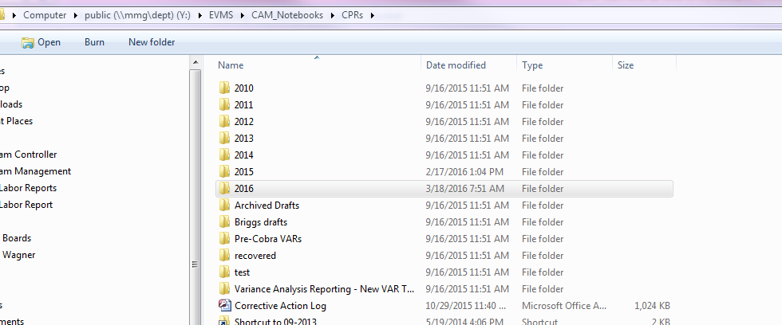

Open up the Corrective Action Log located on the Earned Value Management site on SharePoint.

<http://sharepoint/evm/Lists/Corrective%20Action%20Log/My%20Pending%20Corrective%20Actions.aspx>

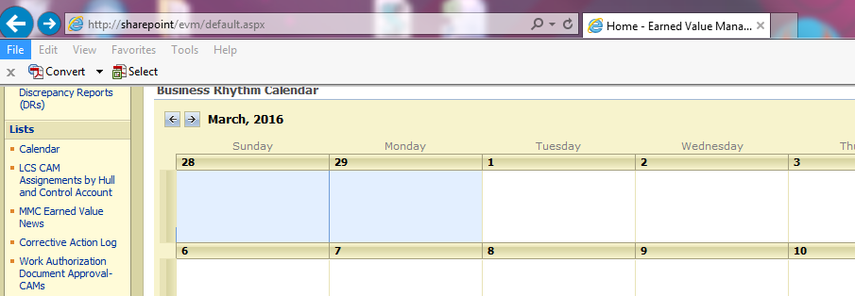

While you are going through the Format 5- If there is an actionable corrective action that is stated in the variance tables, you ***must***log the action. If the corrective action has been completed or needs to be completed, it still needs to get logged.

**Completed Corrective Action-**  Must still get logged and closed out in the Corrective Action Log.

**Format5-** The action was taken care of and completed by month end processing.

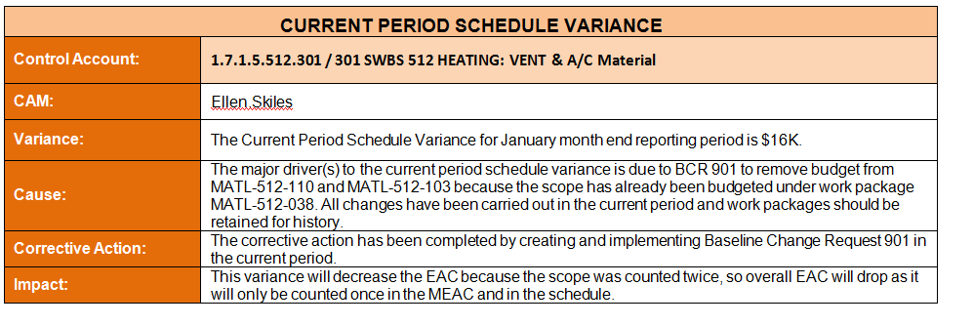

**Corrective Action Log-** Open up a new action if the control account hasn’t already been logged and in active status. You have to search the actions that are showing ***active*** in the status. ***(Note: If the control account is already is logged with the same variance type and corrective action, you have to edit the due date and add to the corrective action the month/ yr and continued action under the previous action.)***

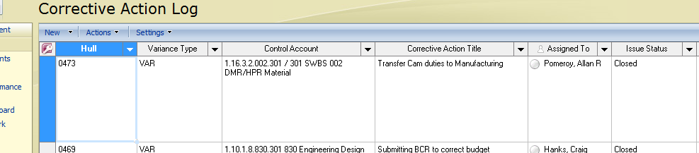

**Continued Action example:**

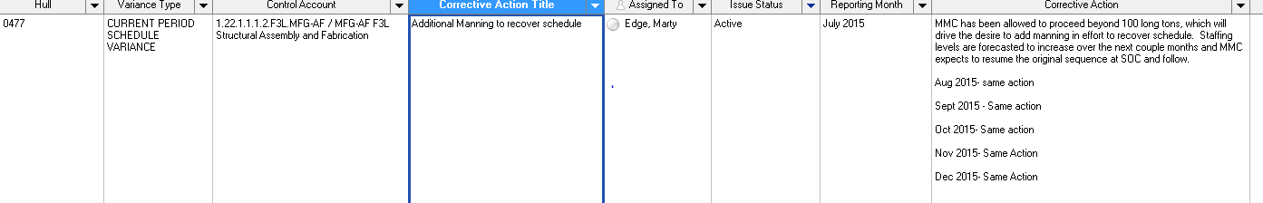

**Logging New Action That is Completed in Financial Reporting Period- After clicking New fill out the log info shown below (make sure you fill out “Action Taken” and change the status to “Closed”**

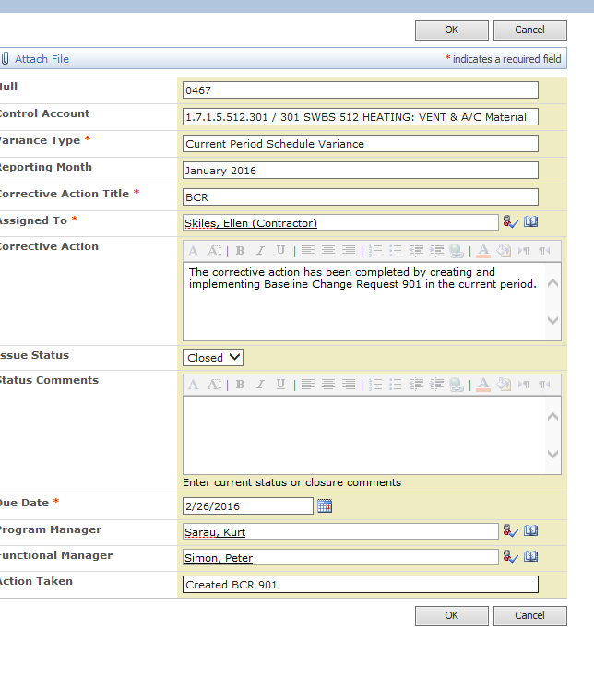

**If new action that still needs to be logged. Fill out the same as above but leave the “Issue Status: Active” and DON’T Fill OUT “ACTION TAKEN”**

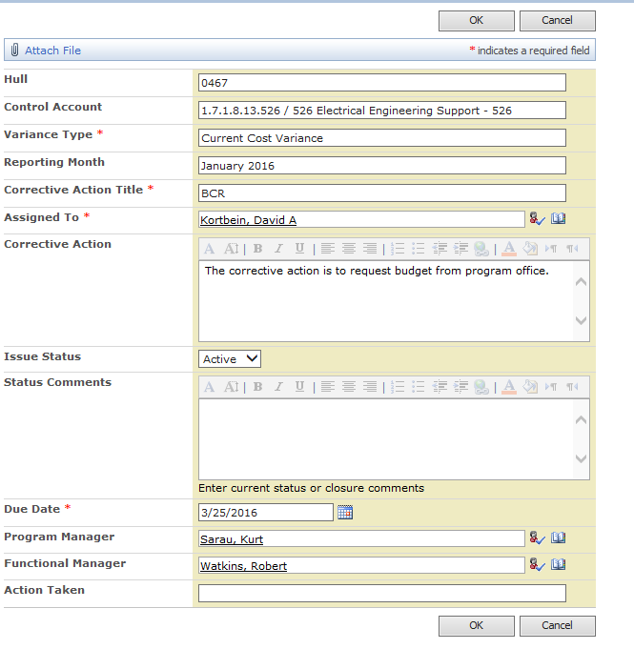

After everything is logged that needs to be- Go to the Corrective Action table and filter the “**ACTIVE**” actions that are outstanding from the “**DUE DATE**” Every couple weeks, try to check for outstanding actions.

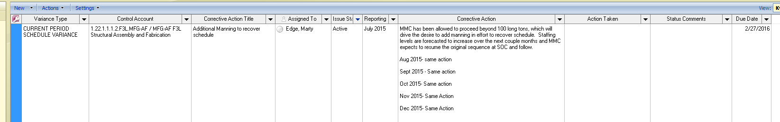

**OR** you can run the **QUERY** located in the **CAM-Notebooks.**

**Y:\EVMS\CAM_Notebooks\06 - CAP Explanations, Variance Reviews, Corrective Actions\Corrective Action Logs**

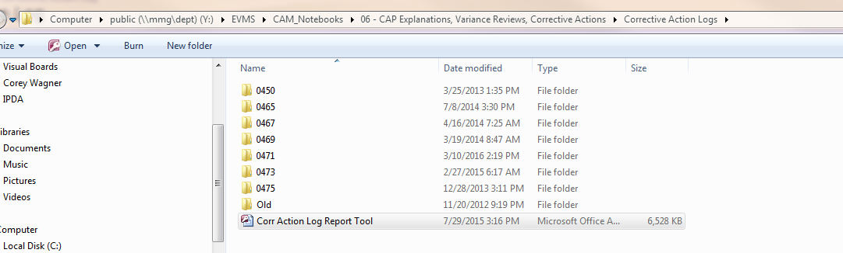

You can choose the query you need to run by open days left, hull specific, closed, etc. Just double click the report you want.

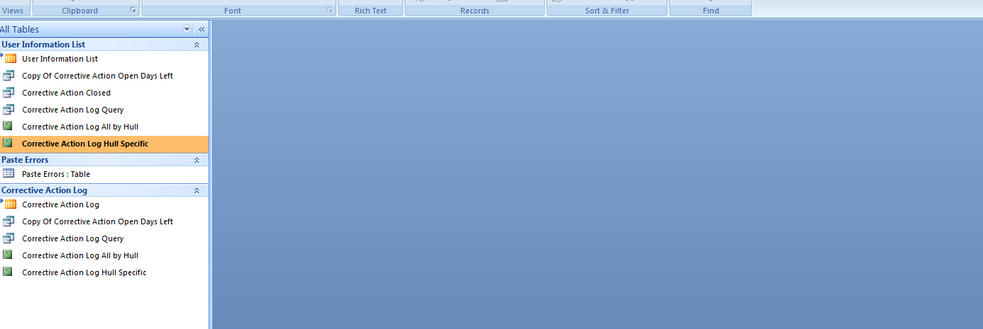

**Notify the CAMs that have outstanding actions to status update the open action in the “Status Comment” section of the log if they have to still complete the action. If they completed the action, inform them to close the action and fill out the “Action Taken” section of the log on. For example- If they needed more budget, They would have created a BCR for the control account. They would put “Created BCR 12 for more budget”.**